**Assignment 3**

**Student Name:** Sahil Kaundal **UID:** 21BCS8197

**Branch:** BE CSE (Lateral Entry) **Section/Group:** 807/B

**Semester:** 4th **Date of Performance:** 06/05/2022

**Subject Name:** MPI **Subject Code:** 20CSP-252

**Q1.**

**Describe the function of the following pins in 8086 maximum mode of operation:**

**(i) TEST                    (ii) RQ/GT0 and RQ/GT1**

**(iii) QS0 and QS1     (iv) s0, s1, s2.**

**Answer:**

1. ***TEST:***

* It is an active low input line dedicated for 8087 co-processor.
* In Maximum Mode whenever the co-processor is busy it makes this pin high.
* ***TEST*** input is examined by the ***WAIT*** instruction.
* If this pin is high, the microprocessor enters idle state; till ***TEST*** pin becomes low i.e.,8087 is free.

1. ***RQ/GT0:***

* In Maximum Mode it carries the bi-directional Request/Grant signal.
* The external bus master (8089 or 8087) sends an active low pulse to request for the control over the system bus.
* In response the 8086 completes the current bus cycle, releases the system bus and sends an active low Grant pulse on the same line to the external bus controller.
* 8086 gets back the system bus only after external bus master sends an active low release pulse on the same line.

***RQ/GT1:***

* This has the same function as ***RQ/GT0*** in maximum mode but it is of lower priority.

1. ***QS0 and QS1:***

* In Maximum Mode it is used to indicate the ***Instruction Queue Status***.
* When ***QS1 and QS0*** are ***00*** then Queue status indicates no operation.
* When ***QS1 and QS0*** are ***01*** then the Queue status indicates that first byte of opcode is to be fetched from the queue.
* When ***QS1 and QS0*** are ***10*** then the Queue status indicates to empty the queue.
* When ***QS1 and QS0*** are ***11*** then the Queue status indicates that subsequent byte is to be fetched from the queue.
* Refer following table.

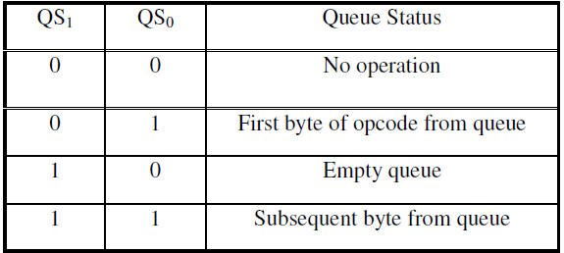

1. ***S0, S1, S2:***

* In Maximum mode these are used to generate proper control signal.
* Following table shows the operation of these pins.

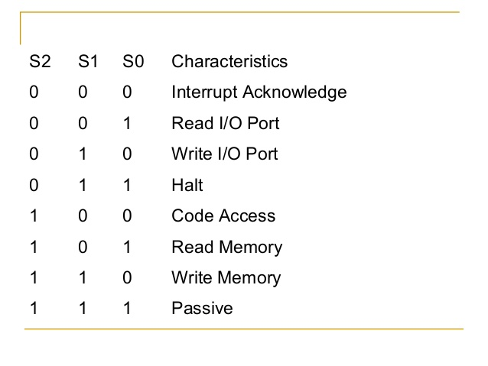

**Q2.**

**If the content of DS and BX register is 2500H and 1000H respectively. From which memory location will 8086 fetch the data while executing instruction MOV CX, [BX].**

**Answer:**

Content of DS and BX register is 2500H and 1000H, respectively.

In microprocessor 8086, we have AX, BX, CX, DX and DS as registers. AX is called the accumulator. Each register is used to store values and perform operations.

Microprocessors use assembly language to perform functions.

MOV instruction is used to move contents from one register to other. The content where it is present is called the source register and where it is moved is called the destination register.

To move contents from DS to BX, use command:

MOV BX, [DS]

Here DS is the source register on the left and BX is the destination register on the right. Content will be moved from the register mentioned in the right to the register mentioned in the left. So content will be moved from DS to BX.

**When the contents of DS and BX register is 2500H and 1000H respectively,**

**1000H memory location will fetch the data while executing instruction MOV CX, [BX].**

**Evaluation Grid (To be created as per the SOP and Assessment guidelines by the faculty):**

|  |  |  |  |
| --- | --- | --- | --- |
| Sr. No. | Parameters | Marks Obtained | Maximum Marks |
| 1. |  |  |  |
| 2. |  |  |  |
| 3. |  |  |  |
|  |  |  |  |